**NAAN MUDHAVAN**

**ASSIGNMENT DOCUMENT**

**COURSE TITLE** : DIGITAL MARKETING

**COLLEGE CODE** : 1105

**COLLEGE NAME** : GOJAN SCHOOL OF BUSINESS AND TECHNOLOGY

**NM ID** : 54A91801D802C6A9DF846CB634A302D2

**NAME** : SANJAY V

**REGISTER NUMBER** : 110520106333

**YEAR** : 4TH YEAR

**DEPARTMENT** : ELECTRONICS AND COMMUNICATION ENGINEERING

1. Create a blog or website using Blogspot and Wordpress. Customize the theme design and post new article with 500 words

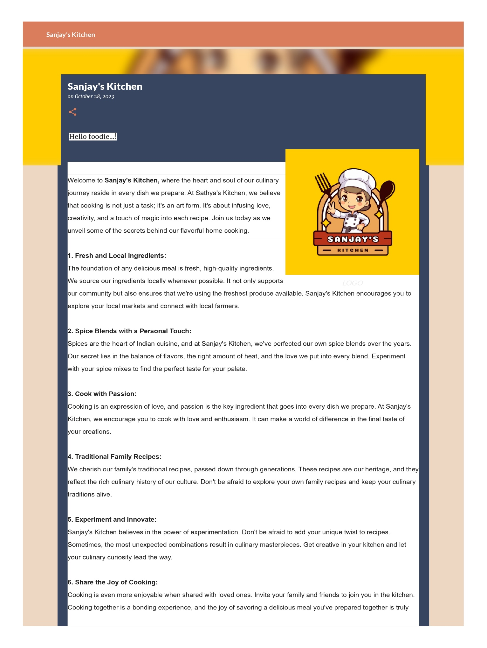Link: <https://sanjayskitchen23.blogspot.com/2023/10/sanjays-kitchen.html>

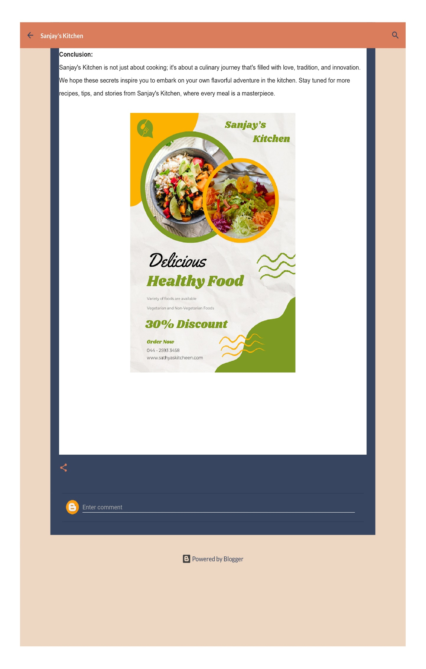

1. Create a New Facebook Business Page and post one social media poster for your brand.

Link: <https://www.facebook.com/sanjayskitchen23>

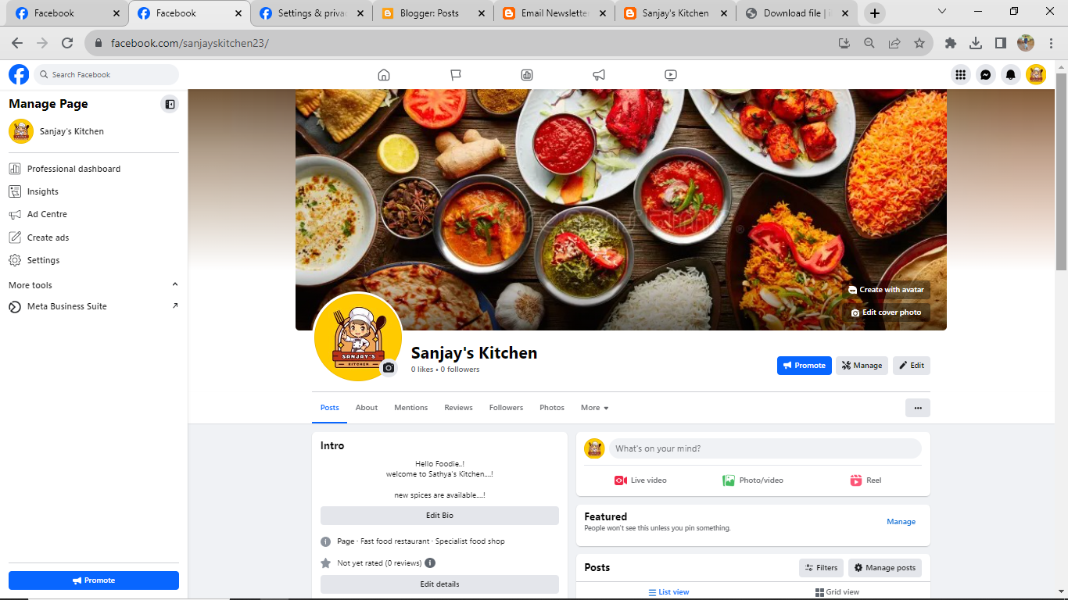

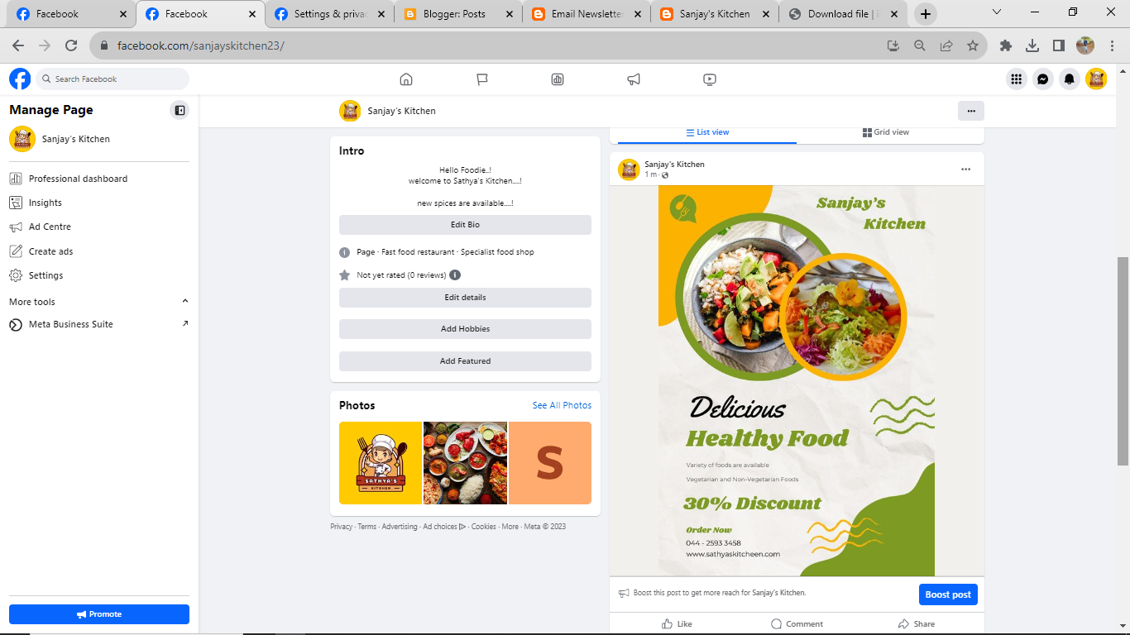

1. Create and design a social media advertisement poster using canva.

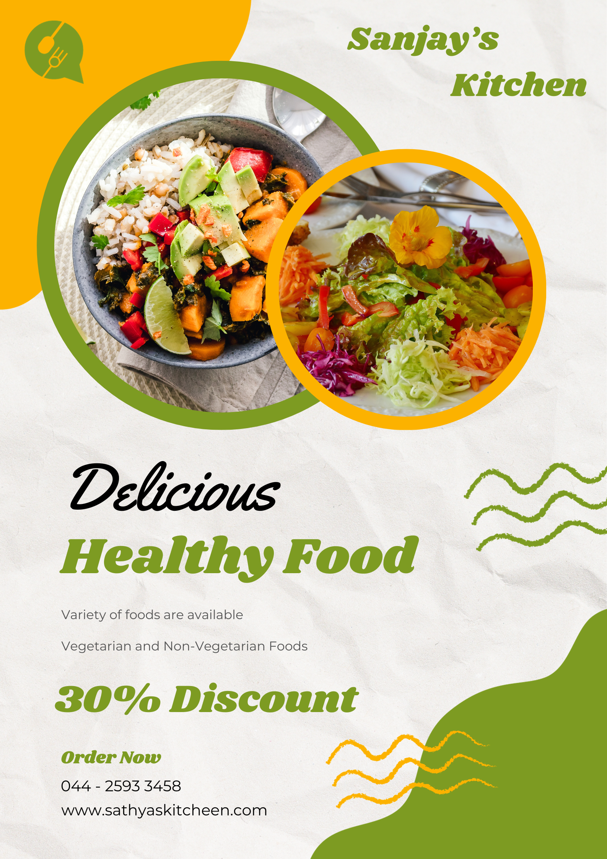

1. Create email newsletter design using MailChimp or canva tool.

Link: <https://sanjayskitchen23.blogspot.com/2023/10/email-newsletter-sanjays-kitchen.html>

